**Unemployment Visualization**

Software Engineering

ITSC-3155

Final Project Report

May 5th, 2020

Group:12

Yushan He

Danait Teklemariam

Justin Scott

Vianca Barlis

**Table of Contents**

**1. INTRODUCTION 1**

1.1 Purpose 1

1.2 Scope 1

1.3 Definitions, Acronyms, and Abbreviations 1

1.4 Context Diagram and Data Flow Diagram 1

1.5 References 1

1.6 Overview 1

**2. GENERAL PROJECT DESCRIPTION 2**

2.1 project Perspective 2

2.2 project components 2

2.3 specific goals 3

2.4 overview of programs related to specific goals 3

2.5 Assumptions and Dependencies 3

**3. EFFORT 3**

3.1 effort 3

**4. PROGRAMS DEVELOPED 4**

4.1 User Interfaces *4*

4.2 Comparison 5

**5. DISCUSSIONS AND CONCLUSION 6**

5.1 Discussions 6

5.2 What can be concluded 6

# **1. Introduction**

Today, Covid-19 is affecting the whole world, from health to economy. Without the medication, many countries and governments have implemented stay-at-home orders. Millions of people got unemployment because of Covid-19. As the coronavirus crisis continues to affect the US economy, the number of unemployment keeps rising rapidly. So that we will be looking into the unemployment rates in the U.S.A as of 2020 and create our own visualization chart that will represent what we have learned.

## *1.1 Purpose*

We propose to collect and analyze the unemployment rates in the U.S.A from March 2000 to March 2020. We are going to look at datasets for unemployment benefit claims and the unemployment rates in different age ranges, races and gender. We will collect data from the U.S. Bureau of Labor. After the collection and analysis of data, we will then create a visualization that will represent our project.

## *1.2 Scope*

The scope of this project is to gather datasets that will reflect the unemployment rates in the United States of America. These datasets will be collected from credible governmental sources in order to make sure our project reflects the real statistical data of unemployment. These data sets will be the rates from the year 2000 all the way to 2020. By doing so the data will be analyzed to create our own dataset that will portray what we have learned from those datas. An easily implemented and accessible presentation after generating the dataset is the end result which will be presented with an easy to follow Unemployment Rate Visualization. These charts will clearly show the data easily in different forms of charts. These charts are interactive, barchart, multi line chart, heart map, line chart, stacked bar, buble, and choropleth map. By collecting all of this a dashboard displaying will be created.

These charts will be available to anyone who needs to use them. There are a couple of benefits users can gain from these charts. A dashboard displaying unemployment data from across the country can be vital to one's economic integrity. It would allow anyone viewing it to understand that this rise in unemployment is affecting everyone and that the best decision that they can make would be to stay cautious of how much money is being spent compared to what’s being made. Additional benefit is for providing researchers with all the necessary dates since iit will be collected from different sources. Instead of searching and looking at different sites it will reduce the time researchers would spend on looking for this datas. Instead of wasting their time looking it will be provided to them in a very easily understandable format.

## *1.3 Definitions, Acronyms, and Abbreviations*

COVID-19: An infectious disease caused by a newly discovered CoronaVirus that happened in late 2019, This disease has spread everywhere in the world and affected people's daily life and economy.

## *1.4 References*

<https://www.bls.gov/news.release/laus.nr0.htm> (dataset from each state)

<https://www.bls.gov/charts/employment-situation/civilian-unemployment.htm> (dataset for 20 years)

<https://plotly.com/python/choropleth-maps/> (for choropleth map)

## *1.5 Overview*

## Start with preprocessing the data to the usable dataset based on different types of charts. After that convert the dataset to pandas dataframe data type. In order to make it visible, we use Matlab library to plot the dataset. Lastly, we use dash library to design the website. We studied how to preprocess the dataset to a usable dataset. Use the dataset to draw different charts. Last, use python to design a website.

# **2. General Description**

***2.1 Project Perspective:***

This project takes an in depth look at the unemployment numbers from the past 20 years. Taken from the perspective of U.S citizens, the charts and graphs created give users a great view of how the unemployment numbers have changed over the years due to certain causes and how those numbers vary over different races of people.

***2.2 Project Components:***

The project consists of multiple charts and graphs that visualize unemployment data gathered from multiple credible websites. The types of charts are interactive line charts, multi line charts, bar charts, heat maps, stack bar charts, and bubble charts. Some of the charts are interactive which allows the user to access different data, in this case they can access data on different races. There are also spreadsheets that were created to store all of the data we collected and used to plot the data into the charts.

***2.3 Specific Goals:***

The specific goals of the project would be to gather as much data on the unemployment of different races of American citizens and make it accessible to our users. Another goal is to provide accurate unemployment numbers. The last thing we want is to convey false information. Our goal of providing unemployment numbers for different races is very important to us because the pandemic we face together has affected every race in the country and it's important to inform everyone of this.

***2.4 Overview of Programs Related to Specific Goals:***

Each chart implemented in this project follows what's outlined in our goals and that they’re created to convey real information about the unemployment numbers of different races of U.S citizens. For example, the interactive bar chart, stack bar chart, and multi line chart all provide unemployment numbers for different races either at the same time or individually based on which category the user chooses. The others have their own purpose but all provide real and current information.

***2.5 Assumptions and Dependencies:***

Some of the assumptions of the project include: project members will have access to all of the resources they need to complete their individual tasks on time, project members will have access to the needed resources both human and material to complete the project as a whole, and lastly, all equipment including charts and graphs will be working condition. Two dependencies for this project would be the unemployment data collected for the charts. The project is dependent on the data because without it we can’t create any charts. Another dependency would be making sure the data files are implemented into the code correctly. If this is done incorrectly then the charts won’t show any data.

# **3. Effort**

|  |  |  |  |  |
| --- | --- | --- | --- | --- |
| Task | Estimated Time of Research | Actual Time of Research | Estimated Coding Effort | Actual Coding Effort |
| 1. Search for useable dataset | 1 hr | 2 hrs | N/A | N/A |
| 2 Preprocessing dataset | 30 mins | 45 mins | 1 hr | 1.5 hr |
| 3 Plot dataset | 1 hr | 1 hr | 3 hr | 4 hr |
| 4 Design website dashboard | 1 hr | 1 hr | 2.5 hrs | 3.4 hrs |
| 5 Debug | 2 hrs | 1 hr | 2 hrs | 2.5 hrs |

# **4. Programs Developed**

***4.1 User Interfaces:***

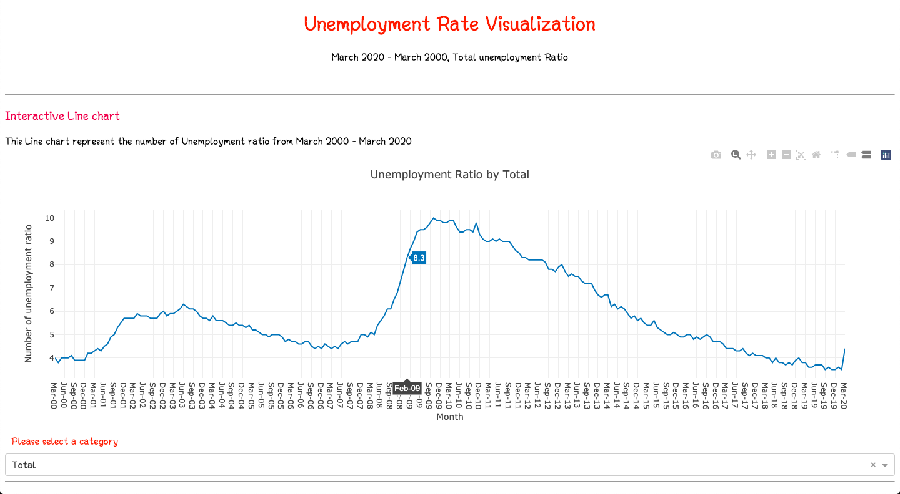

***4.2 Comparison:***

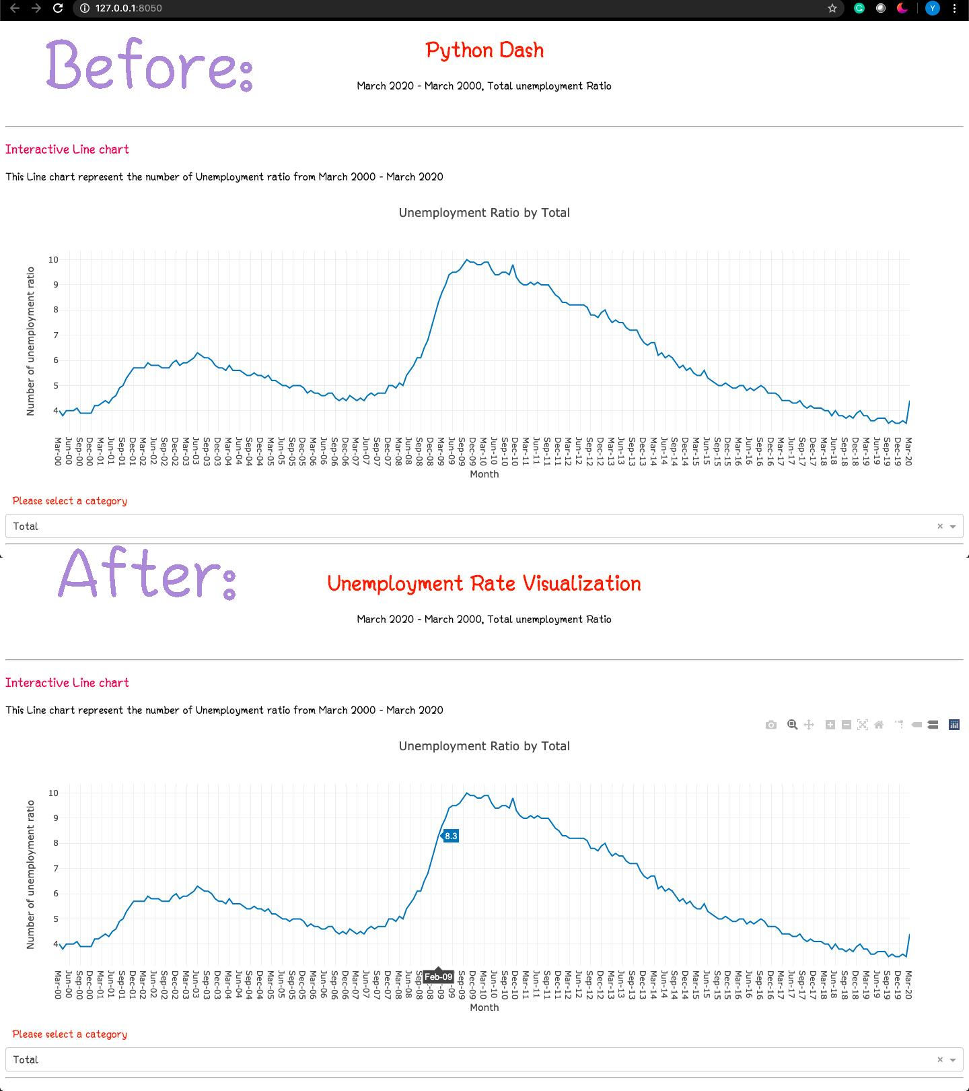

*Before was without this map.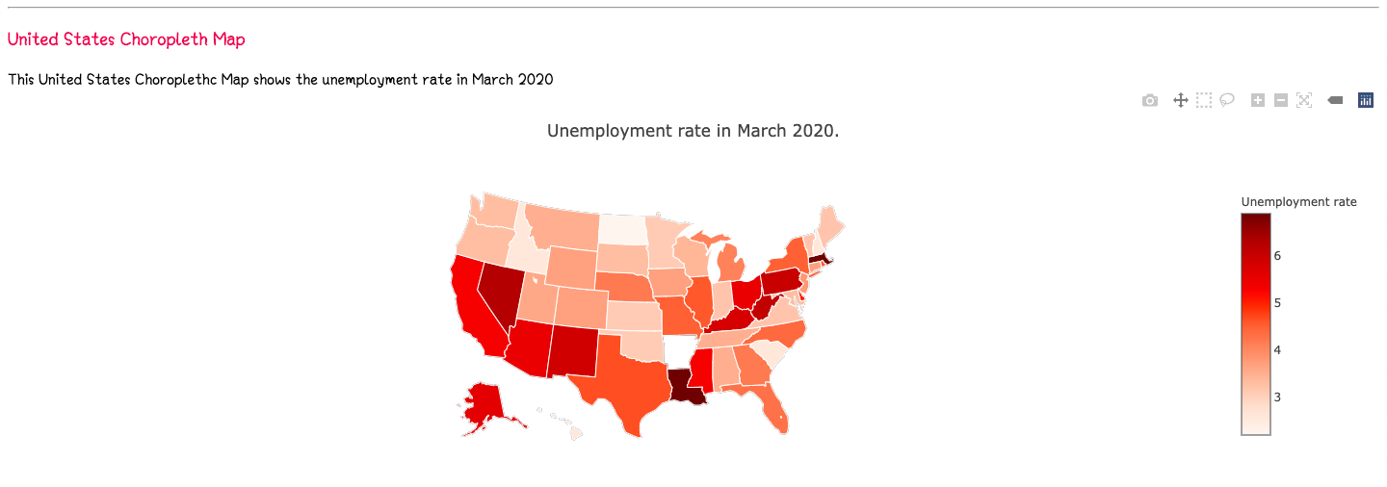*

*The differences code: We added these codes.*

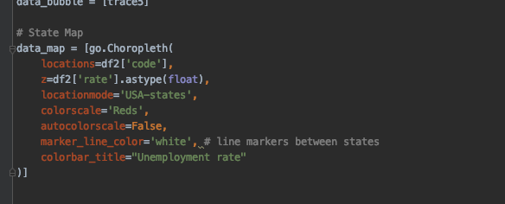

# **5. Discussions and Conclusions**

***5.1 Discussion***

In the discussion of this project, the team has communicated and gathered credible sources together. The communication was through texting and GroupMe. When needing to present, the team uses Google Hangouts to get in contact with everyone on the team.

During our discussions, we set times when the project is to be worked on. We then separate the sections and work equally to complete the tasks. The team has worked a lot and all equally together to produce the best results of the datasets.

***5.2 Conclusion***

In conclusion, working on this project has taught all of us so much. Starting from the basic meetings when we first started the project. At first we had some challenges coming up with potential topics that interest all of us. Then the idea of performing the unemployments visualizations dashboard came up we all agreed since it is one of the very highly speaking topics as the unemployment rates keep increasing due to COVID-19. These challenges are affecting so many people all around the world. After agreeing on a topic we all delegate the work on who does what in order to make sure we have an extraordinary project and everyone contributes equally.

The challenges the team faced were not as many as we expected. Since producing the charts on the datasets were done in labs in class, we did our charts similar to those labs. However, since we split the charts, when sending the code to one person who collected all the charts, we had trouble with running those snips of codes all together. The person who collected those items made some minor changes to the code and it ran well.

We learned a lot from working on this project. First, we learned how to analyze charts. By analyzing the charts, we can see how COVID-19 has affected the people in the United States. The unemployment rate has drastically plummeted, however, it is not as bad as it was in 2008-2010 because of the recession. Second, we learned how to create charts using python and a dataset in a CSV file. Finally, we learned how the economy in the U.S. is crashing because of the decrease in work productivity.